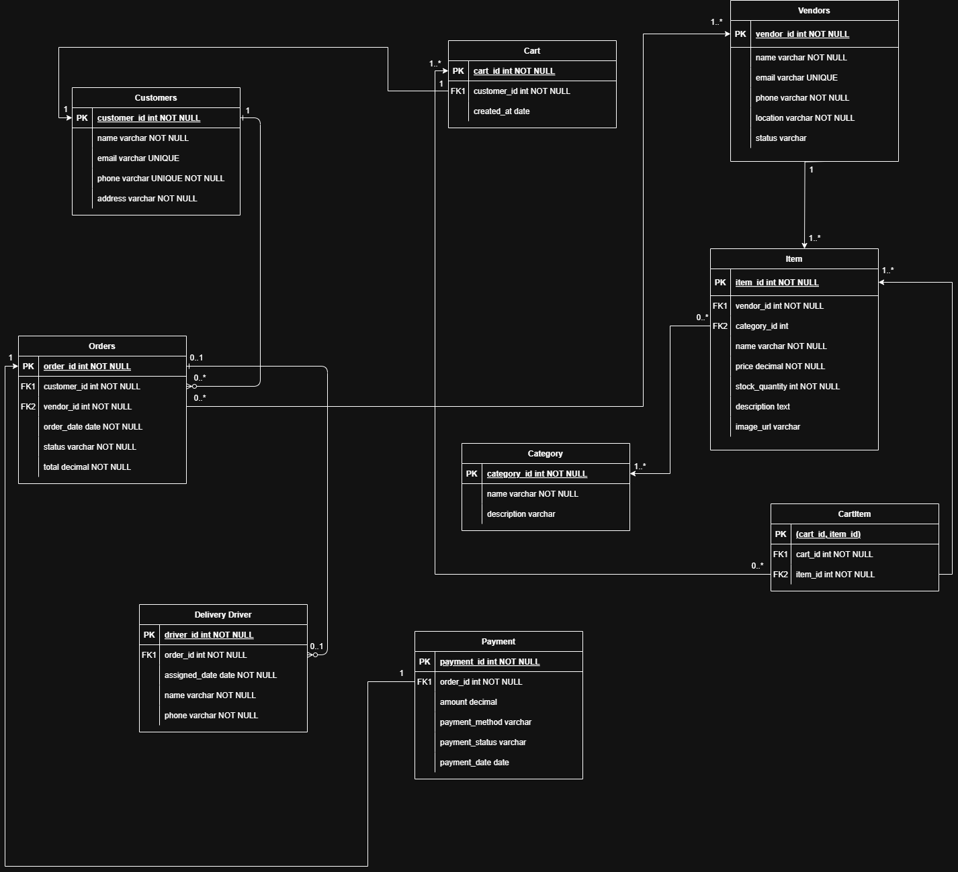**ENTITY RELATIONSHIP DIAGRAM**

**Entities and their Descriptions:**

**1. Customers**

* Stores customer data (name, email, phone, address).
* Each customer can have **one or more carts** and **multiple orders**.
* customer_id is the **Primary Key**.

**2. Vendors**

* Represents businesses or sellers.
* Holds vendor contact info and location.
* Vendors are linked to multiple **items** and receive **orders**.
* vendor_id is the **Primary Key**.

**3. Cart**

* Tracks shopping carts per customer.
* Each cart belongs to **one customer**, but customers can have multiple carts (historically).
* Related to CartItem to store which items are in each cart.

**4. Item**

* Represents the actual products sold.
* Each item is tied to a **vendor** and a **category**.
* Includes price, stock, description, and image.
* item_id is the **Primary Key**.

**5. CartItem**

* A bridge (junction) table for **Cart** and **Item** (many-to-many relationship).
* Stores which items are in which cart.

**6. Category**

* Categorizes items for filtering or browsing.
* Each category can have multiple items.
* category_id is the **Primary Key**.

**7. Orders**

* Contains placed orders.
* Linked to **customers**, **vendors**, and optionally **delivery drivers**.
* Includes order status, total price, and order date.

**8. Delivery Driver**

* Each driver is assigned to an order (one-to-one or optional).
* Includes name, phone, and assigned date.

**9. Payment**

* Each order has one payment record.
* Includes amount, method, status, and date of payment.